EXPERIMENT – 11
Change Hardware compatibility of a VM (Either by clone/create new one) which is already created and configured, using virtual box.
Aim:
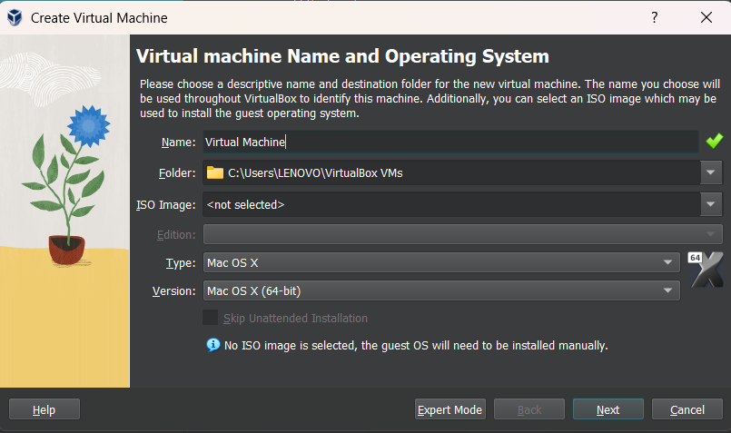
To change the hardware configuration of an already created and configured Virtual Machine using VirtualBox.
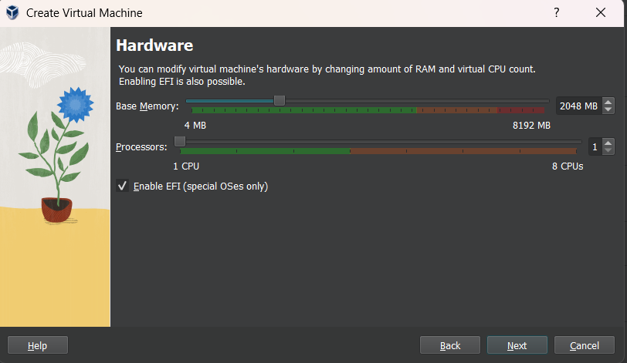

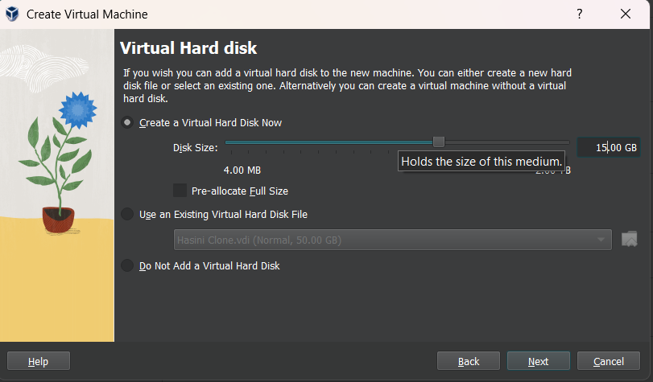

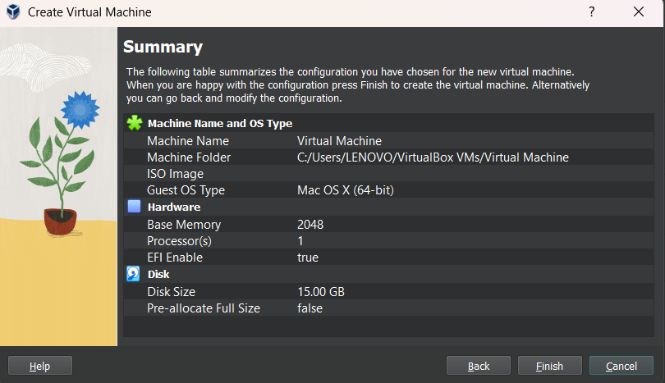
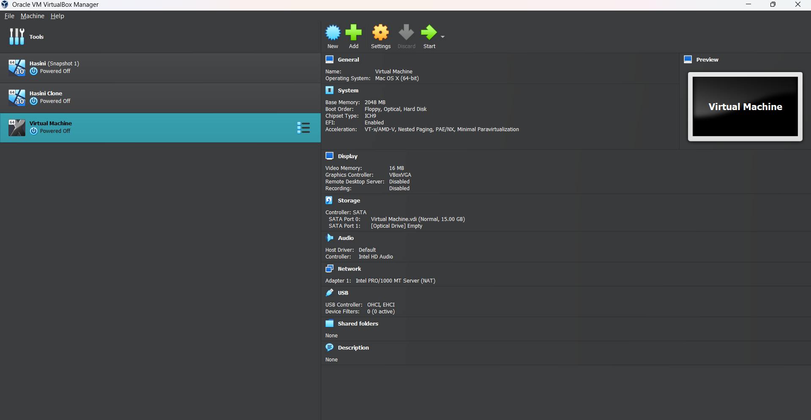

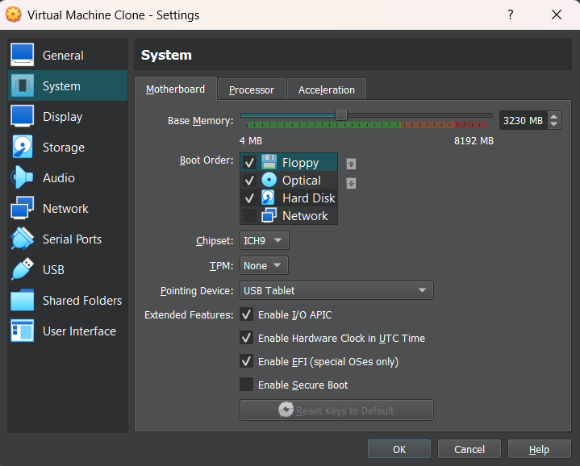

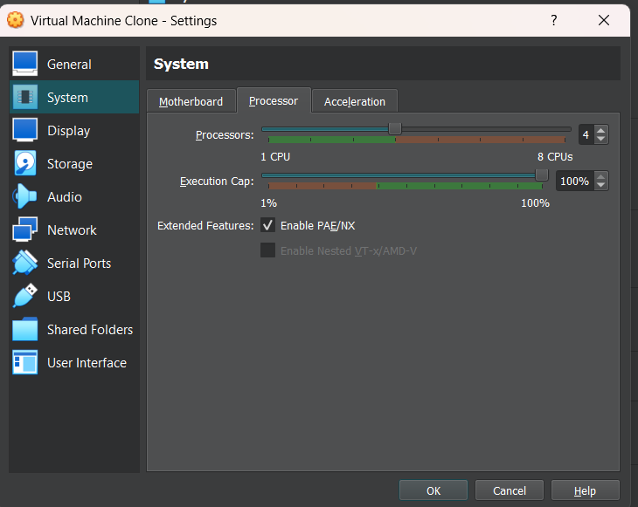

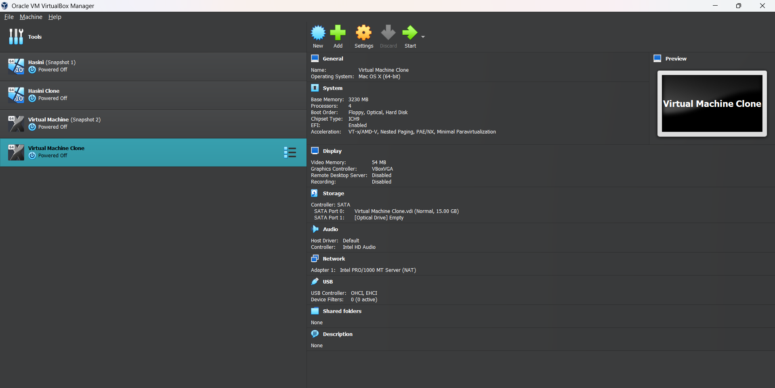
Result:
The hardware compatibility of the VM was successfully modified in VirtualBox. The VM ran correctly after changing RAM, CPU, storage, and other hardware settings, demonstrating hardware reconfiguration in a Type-2 Hypervisor.

